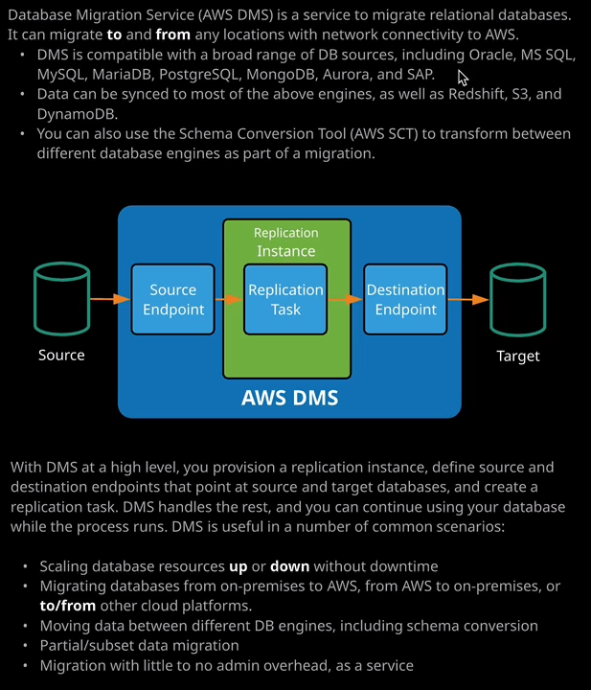

Welcome back and in this lesson I want to cover the Database Migration Service or DMS. Now, this is a product that I'm not going to be doing any demo on because it's something that, at least for the Solutions Architect Associate Exam, you just need to be aware of the theory. Essentially, DMS is a service that allows you to my great relational databases. It could be used to migrate to and from any locations with network connectivity to AWS. Now, before I talk about the features of DMS, it's useful, I think, to reflect on what a traditional database migration might look like.

Generally you've got two ways to migrate a database. **You can either do a backup and restore migration, and this essentially means that you have to stop all input and output on the existing database. You need to perform a full backup of that database, take the backup somewhere else, do restore, and then change all of your applications which utilize that database to point at the new endpoint. Now whilst this is safe there is a lot of admin overhead, and it does require a full outage during the migration process and for large databases, this could be days or even weeks.**   
The second type of migration generally involves **some form of replication, so you have to configure a replication between a source and the destination, allow that replication to take all of the existing data and bring the databases into parity and then migrate any new transactions from the source to the destination. Now this does result in very little, if any, downtime, because the final migration process is simply moving your applications to point at the new endpoint and that new endpoint, if the process is followed correctly, should have the same data as the source. Now the problem is this is fairly complex to set up, and it is fairly admin intensive. So this tends to be the method that's employed for production, database migrations or anything that's larger that would support a backup and restore method but it does take a lot of skill, and it is really complex.**

So DMS is essentially a product which handles this as a service. The architecture is that pretty much you create a replication instance. So this is actually a compute instance that's running and the sole function of this is to migrate data from the source to the target database. So you define a source endpoint you give it any authentication information that's required, follow the same process for the destination, and whenever this is running its ensuring that all of the data is migrated from the source to the target. Your applications can continue operating on the source database instance until the point at which you want to migrate them all to the target and that's the process complete. It's done a full synchronization. It could operate over whatever timeframe you want it to, and then at the end, you migrate the applications. Now DMS is compatible with a broad range of database sources. These include Oracle, Microsoft SQL, mySQL, MariaDB, PostgreSQL, MongoDB, Aurora, and even SAP. Data can be synced to most of the above engines as well as Red Shift, S3, and DynamoDB. So all of those can be targets. Now DMS also includes a feature called the schema conversion tool, or AWS SCT and that allows you to transform the structure between different database engines as part of a migration. So that's something that, traditionally, without having access to DMS, would be a hugely complex task and it's handled as part of this product. So that something really important to understand. Remember this term schema conversion tool or SCT and that it can transform between different database engines because it is likely to come up in the exam. Now with DMS at a high level, the process is simple. I talked about this earlier in this lesson, you provision a replication instance, you define a source and destination endpoint. You point it a source and target databases, create a replication task, and DMS handles the rest. You can continue using your database while the process runs, and you won't have any interruption in service except when you have to update the applications to point at a new endpoint. So DMS is useful in a number of situations. Maybe you want to scale your database resources up or down without downtime. You can create a new target instance of the new size, replicate the data, and then switch over to that new target instance and decommission the source. Maybe you want to migrate your databases from on premise to AWS from AWS to on premises or even to and from, other cloud platforms DMS is compatible even with databases hosted on other cloud platforms. You can use DMS together with schema conversion tool to move data between different database engines. So that's a full schema conversion. You can use DMS to perform partial or subset data migration so it doesn't have to be a full database and all of that could be done with no admin overhead as a service. You only pay for the time that the replication instance is operational. Now, that's all that you need to know about this service for the exam. At an associate level and specifically the solutions architect associate, you simply need to be aware of the functionality of the product, its main headline features, and exactly when and where you'd use it and I've covered that in this lesson. So go ahead, mark this lesson as complete and when you're ready, you can move on to the next topic where I'm going to be talking about ID Federation and single sign on.